
МИНИСТЕРСТВО НАУКИ И ВЫСШЕГО ОБРАЗОВАНИЯ РОССИЙСКОЙ ФЕДЕРАЦИИ
ФЕДЕРАЛЬНОЕ ГОСУДАРСТВЕННОЕ БЮДЖЕТНОЕ
ОБРАЗОВАТЕЛЬНОЕ УЧРЕЖДЕНИЕ ВЫСШЕГО ОБРАЗОВАНИЯ
«ДОНСКОЙ ГОСУДАРСТВЕННЫЙ ТЕХНИЧЕСКИЙ УНИВЕРСИТЕТ»
(ДГТУ)

Факультет «Информатика и вычислительная техника»
Кафедра «Кибербезопасность информационных систем»

Лабораторная работа №2
по дисциплине: «Методы и средства криптографической защиты информации»
На тему «Реализация элементов схемы шифрования ГОСТ 28147-89»

Выполнил обучающийся гр. ВКБ42
Михайлов Александр Сергеевич

Проверила:
Сафарьян О.А

Ростов-на-Дону
2025
Цель работы: формирование умений шифрования с использованием алгоритма шифрования ГОСТ 28147–89.

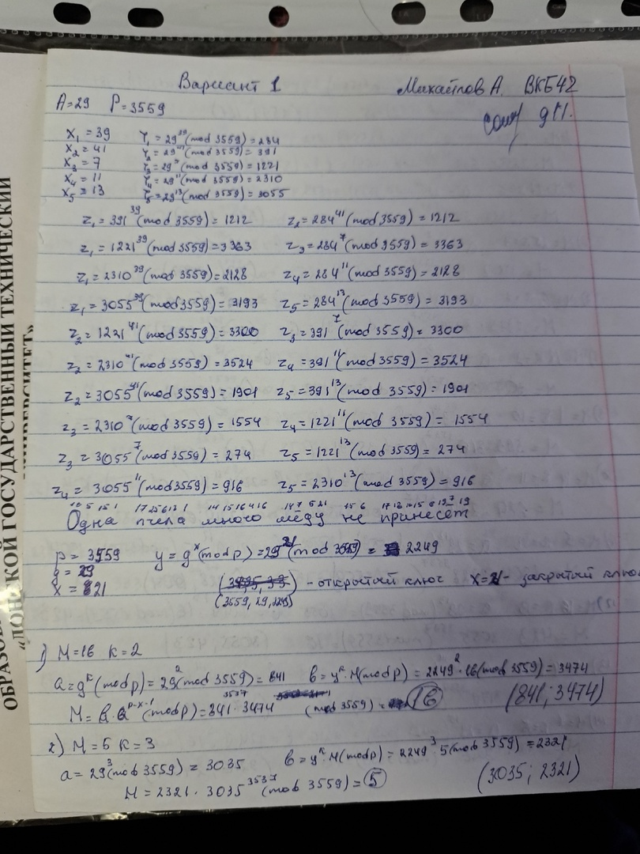
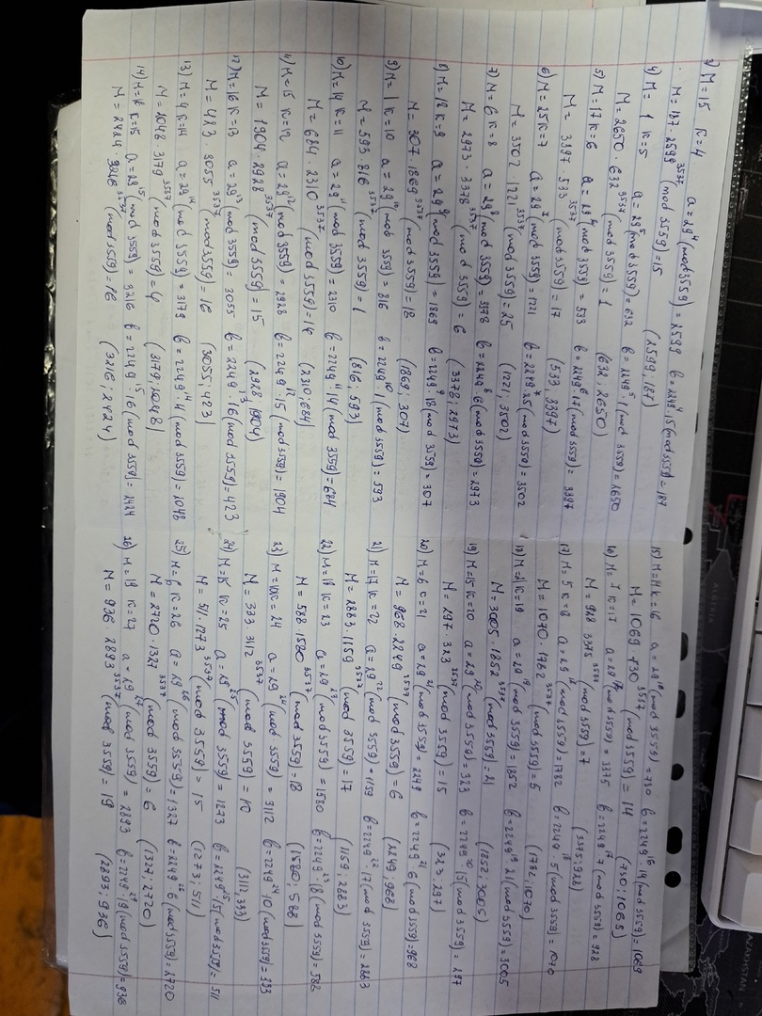
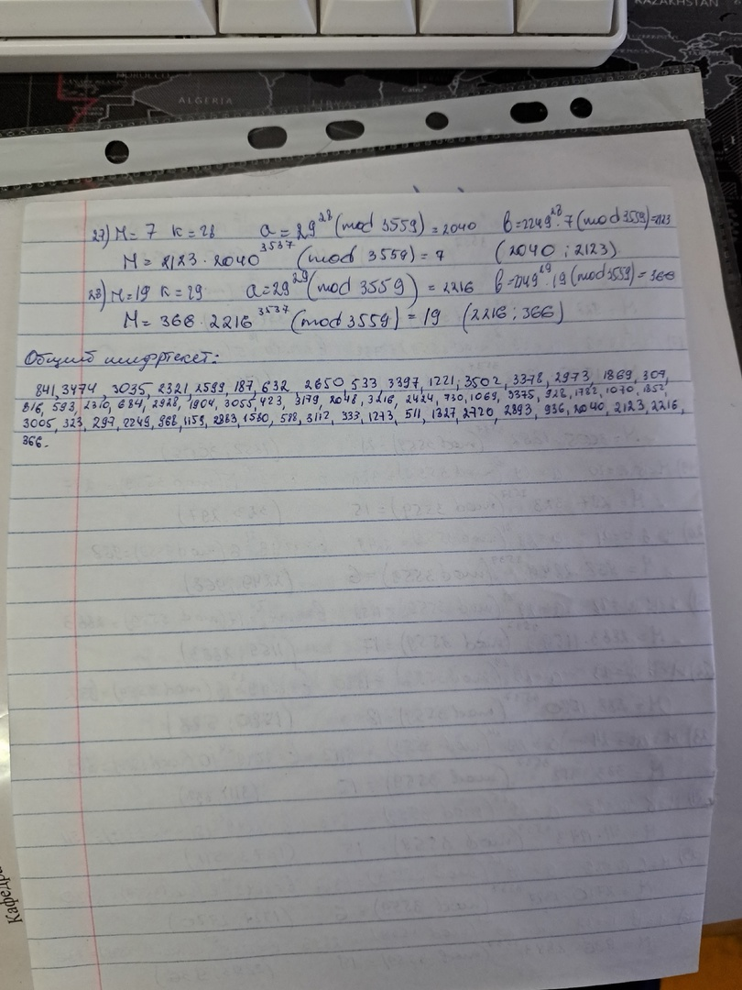

Листинг кода
using System;
using System.Collections.Generic;
using System.ComponentModel;
using System.Data;
using System.Drawing;
using System.Linq;
using System.Text;
using System.Threading.Tasks;
using System.Windows.Forms;

namespace GOST
{
public partial class Form1 : Form
{
private const int BUFF_SIZE = 1024;
private static readonly byte[,] Sbox = new byte[8, 16]
{
{0x9, 0x6, 0x3, 0x2, 0x8, 0xB, 0x1, 0x7, 0xA, 0x4, 0xE, 0xF, 0xC, 0x0, 0xD, 0x5},
{0x3, 0x7, 0xE, 0x9, 0x8, 0xA, 0xF, 0x0, 0x5, 0x2, 0x6, 0xC, 0xB, 0x4, 0xD, 0x1},
{0xE, 0x4, 0x6, 0x2, 0xB, 0x3, 0xD, 0x8, 0xC, 0xF, 0x5, 0xA, 0x0, 0x7, 0x1, 0x9},
{0xE, 0x7, 0xA, 0xC, 0xD, 0x1, 0x3, 0x9, 0x0, 0x2, 0xB, 0x4, 0xF, 0x8, 0x5, 0x6},
{0xB, 0x5, 0x1, 0x9, 0x8, 0xD, 0xF, 0x0, 0xE, 0x4, 0x2, 0x3, 0xC, 0x7, 0xA, 0x6},
{0x3, 0xA, 0xD, 0xC, 0x1, 0x2, 0x0, 0xB, 0x7, 0x5, 0x9, 0x4, 0x8, 0xF, 0xE, 0x6},
{0x1, 0xD, 0x2, 0x9, 0x7, 0xA, 0x6, 0x0, 0x8, 0xC, 0x4, 0x5, 0xF, 0x3, 0xB, 0xE},
{0xB, 0xA, 0xF, 0x5, 0x0, 0xC, 0xE, 0x8, 0x6, 0x2, 0x3, 0x9, 0x1, 0x7, 0xD, 0x4}
};
private static readonly Encoding Windows1251 = Encoding.GetEncoding(1251);
public Form1()
{
InitializeComponent();
}

private void button1_Click(object sender, EventArgs e)
{
byte[] encrypted = new byte[BUFF_SIZE];
byte[] decrypted = new byte[BUFF_SIZE];

Encoding windows1251 = Encoding.GetEncoding("Windows-1251");
string key = textBox1.Text;
byte[] key256b = Windows1251.GetBytes(key);
string OpenText = textBox2.Text;
byte[] buffer = Windows1251.GetBytes(OpenText);
listBox1.Items.Add("Исходное сообщение:");
PrintArray(buffer);
listBox1.Items.Add(Windows1251.GetString(buffer));
int position = GOST_28147(encrypted, 'E', key256b, buffer, buffer.Length);
listBox1.Items.Add("Зашифрованное сообщение:");
PrintArray(encrypted, position);
listBox1.Items.Add(Windows1251.GetString(encrypted, 0, position));
textBox3.Text = (Windows1251.GetString(encrypted, 0, position));
}
private void button2_Click(object sender, EventArgs e)
{
byte[] encrypted = new byte[BUFF_SIZE];
byte[] decrypted = new byte[BUFF_SIZE];

Encoding windows1251 = Encoding.GetEncoding("Windows-1251");
string key = textBox1.Text;
byte[] key256b = Windows1251.GetBytes(key);
string OpenText = textBox2.Text;
byte[] buffer = Windows1251.GetBytes(OpenText);
int position = GOST_28147(encrypted, 'D', key256b, buffer, buffer.Length);
listBox1.Items.Add("Расшифрованное сообщение:");
PrintArray(encrypted, position);
listBox1.Items.Add(Windows1251.GetString(encrypted, 0, position));
textBox3.Text = (Windows1251.GetString(encrypted, 0, position));
}
private byte[] GenerateRandomKey()
{
byte[] key = new byte[32];
using (var rng = new System.Security.Cryptography.RNGCryptoServiceProvider())
{
rng.GetBytes(key);
}
return key;
}
public int GOST_28147(byte[] to, char mode, byte[] key256b, byte[] from, int length)
{
length = (length % 8 == 0) ? length : length + (8 - (length % 8));

uint N1, N2;
uint[] keys32b = new uint[8];
Split256BitsTo32Bits(key256b, keys32b);
for (int i = 0; i < length; i += 8)
{
byte[] block = new byte[8];
int bytesToCopy = Math.Min(8, from.Length - i);
Array.Copy(from, i, block, 0, bytesToCopy);
if (bytesToCopy < 8)
{
for (int j = bytesToCopy; j < 8; j++)
{
block[j] = 0x20;
}
}
Split64BitsTo32Bits(Join8BitsTo64Bits(block, 0), out N1, out N2);
FeistelCipher(mode, ref N1, ref N2, keys32b);
Split64BitsTo8Bits(Join32BitsTo64Bits(N1, N2), to, i);
}

return length;
}
static void Split256BitsTo32Bits(byte[] key256b, uint[] keys32b)
{
for (int i = 0; i < 8; ++i)
{
keys32b[i] = BitConverter.ToUInt32(key256b, i * 4);
}
}
static void Split64BitsTo32Bits(ulong block64b, out uint block32b_1, out uint block32b_2)
{
block32b_2 = (uint)(block64b & 0xFFFFFFFF);
block32b_1 = (uint)(block64b >> 32);
}
static ulong Join8BitsTo64Bits(byte[] blocks8b, int startIndex)
{
ulong block64b = 0;
for (int i = 0; i < 8; ++i)
{
block64b = (block64b << 8) | blocks8b[startIndex + i];
}
return block64b;
}
public void FeistelCipher(char mode, ref uint block32b_1, ref uint block32b_2, uint[] keys32b)
{
switch (mode)
{
case 'E':
case 'e':
int count = 0;
for (int round = 0; round < 24; ++round)
{
count++;
RoundOfFeistelCipher(ref block32b_1, ref block32b_2, keys32b, round, count);
}
for (int round = 31; round >= 24; --round)
{
count++;
RoundOfFeistelCipher(ref block32b_1, ref block32b_2, keys32b, round, count);
}
break;

case 'D':
case 'd':
count = 0;
for (int round = 0; round < 8; ++round)
{
count++;
RoundOfFeistelCipher(ref block32b_1, ref block32b_2, keys32b, round, count);
}
for (int round = 31; round >= 8; --round)
{
count++;
RoundOfFeistelCipher(ref block32b_1, ref block32b_2, keys32b, round, count);
}
break;
}
}
public void RoundOfFeistelCipher(ref uint block32b_1, ref uint block32b_2, uint[] keys32b, int round, int count)
{
uint key = keys32b[round % 8];
listBox1.Items.Add($"Раунд {count}:");
listBox1.Items.Add($" N1: {block32b_1:X8}, N2: {block32b_2:X8}");
listBox1.Items.Add($" Ключ: {key:X8}");

uint result_of_iter = (block32b_1 + key) % uint.MaxValue;
listBox1.Items.Add($" После сложения: {result_of_iter:X8}");

result_of_iter = SubstitutionTable(result_of_iter);
listBox1.Items.Add($" После S-блоков: {result_of_iter:X8}");

result_of_iter = LShiftNBit(result_of_iter, 11, 32);
listBox1.Items.Add($" После сдвига: {result_of_iter:X8}");

uint temp = block32b_1;
block32b_1 = result_of_iter ^ block32b_2;
listBox1.Items.Add($" После XOR: {block32b_1:X8}");

block32b_2 = temp;
if (count != 32)
{
listBox1.Items.Add($" Замена N1: {block32b_1:X8}, Замена N2: {block32b_2:X8}");
}
}
static uint SubstitutionTable(uint block32b)
{
byte[] blocks4bits = new byte[8];
Split32BitsTo4Bits(block32b, blocks4bits);
SubstitutionTableBy4Bits(blocks4bits);
return Join4BitsTo32Bits(blocks4bits);
}
static void SubstitutionTableBy4Bits(byte[] blocks4b)
{
for (int i = 0; i < 8; ++i)
{
int sbox_row = 7 - i;
byte block4b = (byte)(blocks4b[i]);
blocks4b[i] = Sbox[sbox_row, block4b];
}
}
static void Split32BitsTo4Bits(uint block32b, byte[] blocks4b)
{
for (int i = 0; i < 8; ++i)
{
blocks4b[i] = (byte)((block32b >> (4 * (7 - i))) & 0x0F);
}
}
static uint Join4BitsTo32Bits(byte[] blocks4b)
{
uint block32b = 0;
for (int i = 0; i < 8; ++i)
{
block32b |= (uint)(blocks4b[i] << (4 * (7 - i)));
}
return block32b;
}
static uint LShiftNBit(uint x, int L, int N = 32)
{
return (x << L) | (x >> (N - L));
}
static void Split64BitsTo8Bits(ulong block64b, byte[] blocks8b, int startIndex)
{
for (int i = 0; i < 8; ++i)
{
blocks8b[startIndex + i] = (byte)(block64b >> ((7 - i) * 8));
}
}
static ulong Join32BitsTo64Bits(uint block32b_1, uint block32b_2)
{
return ((ulong)block32b_2 << 32) | block32b_1;
}
public void PrintArray(byte[] array, int length = -1)
{
if (length == -1) length = array.Length;
string result = "[ " + string.Join(" ", array.Take(length).Select(b => b.ToString("X2"))) + " ]";
listBox1.Items.Add(result);
}

private void textBox1_TextChanged(object sender, EventArgs e)
{

}

private void button3_Click(object sender, EventArgs e)
{
byte[] randomKey = GenerateRandomKey();
string keyString = Windows1251.GetString(randomKey);
textBox1.Text = keyString;
}
}
}

